Hayrına Sınav Notları

Software Requirements Specification

Version 5.0

28.05.2017

Enes Emre Akbulut / 2013502153

İsmail Elkıran / 2013502156

Sinem Delihüseyinoğlu / 2009501090

Batuhan Ünal / 2010502054

Prepared for

MIS326-2017

# Revision History

|  |  |  |  |
| --- | --- | --- | --- |
| **Date** | **Description** | **Author** | **Comments** |
| 01.03.2017 | Version 1.0 | HSN Group |  |
| 14.03.2017 | Version 2.0 | HSN Group | Added: new product function, (donation to charities ), user interface sample and extra info about survey result |
| 19.03.2017 | Version 3.0 | HSN Group | Added:Use Cases |
| 24.04.2017 | Version 4.0 | HSN Group | Added:Analysis and activity diagrams |
| 28.05.2017 | Version 5.0 | HSN Group | Added:2 sequence diagrams and 2 state diagrams |

# Document Approval

The following Software Requirements Specification has been accepted and approved by the following:

|  |  |  |  |
| --- | --- | --- | --- |
| **Signature** | **Printed Name** | **Title** | **Date** |
|  | Albert Özkohen | Instructor, MIS326 |  |
|  |  |  |  |
|  |  |  |  |

**Table of Contents**

**REVISION HISTORY 2**

**DOCUMENT APPROVAL 2**

**1. INTRODUCTION 4**

1.1 Purpose 4

1.2 Scope 4

**2. GENERAL DESCRIPTION 4**

2.1 Product Perspective 4

2.2 Product Functions 5

2.3 User Characteristics 6

2.4 General Constraints 6

2.5 Assumptions and Dependencies 7

**3. SPECIFIC REQUIREMENTS 7**

3.1 External Interface Requirements 7

*3.1.1 User Interfaces* 7

*3.1.2 Hardware Interfaces* 7

*3.1.3 Software Interfaces* 7

*3.1.4 Communications Interfaces* 7

3.2 Functional Requirements 8

*3.2.1 Registration* 10

*3.2.2 Login* 10

*3.2.3 Upload* 11

*3.2.4 Control* 11

*3.2.5 Download* 12

*3.2.6 Comment-Rate* 12

*3.2.7 Search* 12

3.3 Non- Functional Requirements 13

3.4 Use-Cases 14

3.5 Use-Case diagram 32

3.6 Activity Diagram 33

3.7 Class Diagram 41

3.8 Analysis Diagram 42

3.9 Sequence Diagrams 43

3.10 State Diagrams 44

**4. APPENDİXES 45**

4.1 Survey Details 45

4.2 Context Diagram 47

4.3User Interface 48

# 1. Introduction

## 1.1 Purpose

This SRS describes the software functional and nonfunctional requirements for release 1.0 of the Hayrına Sınav Notları. This document is intended to be used by the members of the project team that will implement and verify the correct functioning of the system. Unless otherwise noted, all requirements specified here are high priority and committed for release 1.0.

## 1.2 Scope

Hayrına Sınav Notları is an interactive web platform in which university students can share and download all kinds of course-related materials free of charge and communicate with each other. One main objective is bringing source owners together, who are mostly students and create an alternative note sharing and interaction platform. Beside that we are planning to donate an amount of money for charities by paying for download rates. Corporate accounts will be our main revenue source. We will offer opening corporate accounts which enables companies to publish some contents such as job announcements and their education sets on the platform.

# 2. General Description

## 2.1 Product Perspective

Hayrına Sınav Notları tries to increase academic effectiveness and create sustainable commercial ecosystem for students. For certain payment, companies can make announcements and content publishing on the platform. Also charities will gain some amount of money per downloads. Below table describe other platforms and enable to make comparison in terms of some marketing, functionality and organizational issues:

|  |  |  |  |
| --- | --- | --- | --- |
|  | **notlarim.com** | **Derslerikurtaranadam.com** | **Hayrına Ders Notları** |
| Overview | University Lecture Notes | University Lecture Notes | University Lecture Notes |
| Competitive Advantage | User Friendly Interface | Engagement between users is high | Free access, charity support, business partnerships |
| Target market | University Students | University Students | University Students plus Companies |
| Marketing Strategy | Social Media plus Campus Representative | Social Media plus Campus Representative | Event Organization and workshops etc. |
| Product&Services | Lecture Notes | Lecture Notes | Training videos, Lecture Notes, Career Support |
| Pricing | Document based pricing | Document based pricing | Free download files for user and some corporate training set charged |
| Channels | Social Media  Search Engine | Social Media  Search Engine | Social Media  Search Engine |

## As we found out in our survey, more than 96% of the participants are willing or maybe willing to use a more efficient platform such like the one we are going to create and again more than 93% of them are willing or may be willing to share their sources in such platform (*see in Appendix*). This reports that what we are trying to do is actually what people want to be done.

## Also this platform we are trying to create is going to serve the ability to connect with source owners. In this way any problems that users can face in progress of the gathering information in any subject of their interest is going to be solved. In addition to that, users are going to be discussing some topics which allow us to have a platform with features of a forum type website. This one also increasing communication; which we cannot see in any other platforms, basically functioning in a close way to ours.

## 2.2 Product Functions

**Register:** For specific features, users must be register our site. This process can be done via email or social media profiles (Facebook or Google+)

**Login:** Registered users must be log in our site to benefit from variety of features. This process can be done with social media profiles (auto login) and mail address. Also remember me function will be available.

**Comment and Rate:** User can make a comment for specific contents. These comments are investigated moderators and admins to prevent malicious intentions.

**Search:** To find related course materials and announcements. Users can search with keywords, tags and username.

**Download:** Users can store course materials in their devices.

**Upload:** Volunteer can put course materials in our servers.

**Save**: Provide quick access to content

**Payment**: Required system to get money from corporate-type users.

**Share**: Users can share liked content on social media site.

**Account Delete:** Users can delete their accounts from our database.

**Update User Info:** If some important changes occur, user can update their information on our system.

**File delete:** Some unnecessary files and documents can be removed.

**Course page creating**: This function is enable for registered user and moderators. Related user can create pages which are focused some specific courses.

**User ban:** Users who publish spam and unrelated contents are banned by moderators.

**Reporting:** Admins want to get specific reports which explain site performance and demographic features of users.

**Donation to charities:** System will transfer some amount of money to charities by considering download rates of uploaded materials, and after that transfer a thanks message will be sent to the owner of the material.

You can see detailed flow in appendix with context diagram.

## 2.3 User Characteristics

**Anonymous User:** Anonymous users will be able to see course pages, search through course materials and download them as they wish. Also they can rate and make comment about uploaded materials and send messages in general announcement pages.

**Registered User:** In addition to above privileges, registered users can upload new materials, follow courses and create and join groups.

**Corporate Users:** They have contract with management, that allows them to reach specific students. Also they can upload their course materials and training videos.

**Admin:** Have authorities like file delete-update, delete messages and comments, creating and deleting course pages banning-deleting users and ordering announcements from business companies.

**Moderator:** Beside common authorities, moderators inspects uploaded materials.

## 2.4 General Constraints

The main constraint is motivation of students who provide course materials. These materials should be collected at the beginning of semester or before first exams. Also, students should have required competence to use electrical devices to record and publish course contents.

For our web site, we have to determine right online payment system because a lot of web sites are banned by government because of legal reasons. In growing stage, we need to allocate right servers to deploy huge amount of course materials. Also, we have to work with reliable hosting firms to maintain our web site when demand is increasing.

Copyright issues can be occur. Administration side should be careful to prevent this issues. Also, Suspicious files can be uploaded our server can damage our and clients systems. Strong security precautions had must be implemented. This requirement needs investment in early stage of application

Our user base will change in some specific periods. (Summer time etc.) So, we will try to open this system in September to collect documents and reach right target group. At this stage, all course materials are provided from non-professional users so some quality issues will appear.

We cannot collect enough budget to outsource software and graphical design. So, our system should be builded with using Java or ASP.NET. Also, Photoshop and other tools must be learned by team members.

Lastly, our web site has to be written clearly to implement required updates. Our system has work on common web browser IE 4+, Mozilla, Safari, Chrome, Chrome and mobile devices properly.

## 2.5 Assumptions and Dependencies

**Assumptions:**

**AS-1:** Generally students tend to download lecture notes in exam times to study.

**AS-2:** It is important for companies to reach right student profile.

**AS-3:** Students are more interested in business corporation announcements (internship announcements, seminars etc.)

**AS-4:** Making donation will encourage users to uploading and downloading files.

**AS-5:** Online learning will become more popular among students.

**AS-6:** Students have a tendency to work on handouts because they can find some tricks easily.

**AS-7:** Free downloading change structure of market.

**AS-8:** We will complete and release this project until 01.09.2017 using own resources.

**Dependencies:**

**DE-1:** We have to find students who tend to upload their own course materials to our system.

**DE-2**: Developers must implement requirements and create user friendly website.

**DE-3:** In early stage big companies will not tend to publish any announcements so we investigate small size companies.

**DE-4:** Uploaded material reliability cannot be controlled effectively. So, we have to trust our users.

# 3. Specific Requirements

## 3.1 External Interface Requirements

### 3.1.1 User Interfaces

**UI-1:** Hayrına Sınav Notları System should be user friendly and responsive interface .

**UI-2:** All pages include header and footer menu items. Header menu includes constant subjects such as Anasayfa, Dersler, Partnerlerimiz, Biz Kimiz, İletişim, Announcement. Footer includes Sık Sorulan Sorular,İletişim, Sosyal Medya Hesapları.

**UI-3:** Search toolbar should exist in every page.

**UI-4:** Landing page must describe system capabilities and enable to users reach specific content easily.

You can see sample interface in appendix.

### 3.1.2 Hardware Interfaces

No hardware interfaces have been identified.

### 3.1.3 Software Interfaces

**SI-1:** Hayrına Sınav Notları User Demand (HSN)

**SI-1.1:** HSN databases must store all downloading and uploading requests and user information.

**SI-1.2:** Our system should control that course material is available.

**SI-1.3:** All comments and uploading requests must be forwarding to moderators and s/he checks

their contents.

**SI-2:** Payment System

**SI-2.1:** To allow a Manager to analyze monthly transactions.

**SI-2.2:** To allow a corporate user to make payment.

**SI-2.3:** To collect money and pay required debt.

**SI-3:** Sharing System- To share like content in various social media channels.

### 3.1.4 Communications Interfaces

**CI-1:** Announcement page enable to communicate user each other.

**CI-2:** Update, comment, new registration, and other types of activities are sending to related users via notification or e mail.

## 3.2 Functional Requirements

|  |  |  |  |
| --- | --- | --- | --- |
| ID | Functional Requirement Description | Category | Priority |
| FR1 | Our system must display all documents that are uploaded by users. | Product&Services | 1 |
| FR2 | The HSN must allow users to request specific documents. | Product&Services | 1 |
| FR3 | The HSN must support JPG, JPEG, GIF, PDF, WORD, PPT and Excel file formats. | Product&Services | 1 |
| FR4 | The HSN must control uploaded file size | Product&Services | 2 |
| FR5 | Moderators must be notified by system when course groups are opened and files are uploaded. | Product&Services | 1 |
| FR6 | Companies’ announcements are published in Announcement page | Product&Services | 1 |
| FR7 | Users must be directed to company page when they want to apply specific jobs | Product&Services | 3 |
| FR8 | Users must be directed to payment page when they want to enroll companies’ training sets. . | Product&Services | 1 |
| FR9 | The HSN must display Join and Create Group button. | Event Activity | 2 |
| FR10 | The HSN shall show all information about users. | Event Activity | 3 |
| FR11 | The HSN shall show numbers of download, comments and average rate about specific file.. | Event Activity | 2 |
| FR12 | The HSN must allow to open groups for viewing specific contents. | Event Activity | 1 |
| FR13 | The HSN must allow to users to answer questions about course materials. | Event Activity | 3 |
| FR14 | The HSN allow to moderators or registered user to determine which member join related groups. | Event Activity | 1 |
| FR15 | The HSN must allow registered user to upload course materials. | Event Activity | 1 |
| FR16 | The HSN shall allow all type of users to download course materials | Event Activity | 1 |
| FR17 | The HSN must allow to users register with the site.(Login-Logout) | Registration | 1 |
| FR18 | The HSN shall use the users’ email address as the username for log-in purpose. | Registration | 1 |
| FR19 | The HSN must requires the users to set a password. | Registration | 1 |
| FR20 | The HSN must allow to register and login to site with social media profiles | Registration | 3 |
| FR21 | Companies must create their page with company e-mail addresses | Registration | 1 |
| FR22 | The HSN shall allow users to view and edit their information. | Profile | 2 |
| FR23 | The HSN shall allow companies to view and edit their information. | Profile | 2 |
| FR24 | The HSN must generate reports based on user database and company information. | Report | 1 |

### 3.2.1 Registration

**3.2.1.1 Introduction**

Registration is not required for regular users. Desired people may click register button and start registration process.

**3.2.1.2 Inputs**

E-mail, last name, first name, university name, age, location, gender, department, password.

**3.2.1.3 Processing**

Checking required fields and input format, query if the user is already registered then store user info in database.

Another registration process will be provided by Facebook apis. User can click register with Facebook button and all required info are provided automatically.

Mail addresses are checked by confirmation e-mail which include a link that forwarding users to confirmation page.

**3.2.1.4 Outputs**

Confirmation message appear after sending information.

**3.2.1.5 Error Handling**

Missing fields, required fields and input formats are checked and related reports are displayed

### 3.2.2 Login

**3.2.2.1 Introduction**

Registered users can access restricted areas by login.

**3.2.2.2 Inputs**

Mail address and password.

**3.2.2.3 Processing**

Checking required fields and input format, query if the user exist in the database system allow to user to access else display error message.

Another login process will be provided by Facebook apis. User can click login with Facebook button and all required info are provided automatically.

To improve user experience “Remember me” function is available. E-mail address and password are recognized by system.

**3.2.2.4 Outputs**

After login process user will be forwarded to profile page.

**3.2.2.5 Error Handling**

If the user exist in the database system allow to user to access else display error message.

### 3.2.3 Upload

**3.2.3.1 Introduction**

Registered users and moderators can upload course materials. All type of users must be logged in system.

**3.2.3.2 Inputs**

File name, keyword, description, course, course material

**3.2.3.3 Processing**

Checking required fields and input format, registered user upload course material but if course is not exist in our system, moderator must be notified by system to create new course page. Also system must check file size (under 100MB). At the ending of uploading control process starts.

**3.2.3.4 Outputs**

Success or fail message.

**3.2.3.5 Error Handling**

If the user excess uploading limit error message should be displayed.

### 3.2.4 Control

**3.2.4.1 Introduction**

Only moderators and admins can have this functionality

**3.2.4.2 Inputs**

Course materials, comments and announcements are considered in this function.

**3.2.4.3 Processing**

Moderators are notified via system message after upload and comment request then moderator inspect related contents and decide to publish or reject.

**3.2.4.4 Outputs**

Notification to users.

**3.2.4.5 Error Handling**

If the user excess uploading limit error message should be displayed.

### 3.2.5 Download

**3.2.5.1 Introduction**

All users can download as their wish.

**3.2.5.2 Inputs**

There is no input required.

**3.2.5.3 Processing**

When user click download button server get related files. Users checked by captcha process.

**3.2.5.4 Outputs**

User directed to similar documents pages.

**3.2.5.5 Error Handling**

We cannot assume to encounter with any error.

### 3.2.6 Comment-Rate

**3.2.6.1 Introduction**

All users can rate and comment about material.

**3.2.6.2 Inputs**

Rates will be entered by users in numerical characters. Comment text will be limited by 200 characters.

**3.2.6.3 Processing**

Taken rate info will be stored in material table. Comments will be checked by moderator. Also system must check number of text characters.

**3.2.6.4 Outputs**

Rate value is displayed in real time but for comments there will be pop out that describes situation.

**3.2.6.5 Error Handling**

If user excess text character limit avoiding message will appear.

### 3.2.7 Search

**3.2.7.1 Introduction**

Search function enable to all type of users to reach related material easily. Material names are indexed to increase system search performance.

**3.2.7.2 Inputs**

Keywords, user name and file names can be used in this function.

**3.2.7.3 Processing**

Database operation will be executed by system by depending on the entered values.

**3.2.7.4 Outputs**

Search request results will be displayed on result page.

**3.2.7.5 Error Handling**

There will be no error.

## 3.3 Non-Functional Requirements

|  |  |  |  |
| --- | --- | --- | --- |
| ID | Non Functional Requirement | Category | Priority |
| NFR1 | The HSN shall be available for 24 hours per day. | Availability | 1 |
| NFR2 | The HSN must record all transaction data. | Availability | 1 |
| NFR3 | The HSN shall support for all versions of browsers. | Accessibility | 1 |
| NFR4 | The HSN must be available for all operating systems. | Accessibility | 1 |
| NFR5 | The HSN must be available in all search engines | Accessibility | 1 |
| NFR6 | The HSN shall use authentication service in registration process. . | Security | 2 |
| NFR7 | The HSN shall use re-captcha service in registration process. . | Security | 2 |
| NFR8 | The HSN shall have HTTPS because of increasing security, better referral data. | Security | 1 |
| NFR9 | The HSN shall support minimum 10,000 transactions per day. | Capacity | 1 |
| NFR10 | The HSN shall support minimum 50,000 concurrent sessions. | Capacity | 1 |
| NFR11 | The HSN musr be faster than 70 % on computer and 90% on mobile in page speed (Google Page Speed). | Performance | 2 |
| NFR12 | The HSN shall log in for users in given time. | Performance | 1 |
| NFR13 | The HSN include mailing system to improve user experience. | Performance | 2 |

## 3.4 Use Cases

**1. Register**

|  |  |  |  |
| --- | --- | --- | --- |
| Use Case ID: | 1 | | |
| Use Case Name: | Register | | |
| Created By: | Batuhan Ünal | Last Updated By: | Batuhan Ünal |
| Date Created: | March 18, 2017 | Date Last Updated: | March 18, 2017 |
| Actors: | Anonymus Users | | |
| Description: | For specific features, users must be registering our site. This process can be done via email or social media profiles (Facebook or Google+). | | |
| Preconditions: | 1. Users must enter registration page. 2. Users must fill registration forms. 3. Or users can click social media links to start registration process. | | |
| Postconditions: | 1. System checks that all required boxes are filled by user. 2. System checks all required boxes are filled with appropriate formats. 3. System ensures that entered e-mail address and username does not exist on our database. 4. Users are forwarded to confirmation page. | | |
| Normal Course: | **1.0 Register HSN**   1. Anonymous users want to benefit form more features and decide to register our site. 2. Users click register button which placed all pages 3. Users determine their user names, passwords and enter other information. 4. Lastly, user click Register button and forwarded to confirmation page. 5. After seeing this page, user can check e-mail to obtain confirmation link. 6. After clicking this link, user can access profile page. | | |
| Alternative Courses: | **1.0 Register HSN with Social Media Profiles**   1. Users also use their social media profiles like Facebook or Google+. 2. This process requires some third applications and asks use r preference. | | |
| Exceptions: | **1.0.E.1 Not Appropriate Format**  1. System informs anonymous users to enter correct type.  2a. User cancels the registration.  2b. System guides user about appropriate formats.  **1.0.E.2 Existing Users**  1. System informs users that entered e-mail address or user name are exist in our database.  2a. User cancels the registration.  2b. System offer alternative user names. | | |
| Includes: | None | | |
| Priority: | High | | |
| Frequency of Use: | Approximately 120 users per day. | | |
| Business Rules: | None | | |
| Special Requirements: | 1. The HSN  shall use the users’ email address as the username for log-in purpose. 2. The HSN must requires the users to set a password. 3. The HSN must allow to register and login to site with social media profiles 4. Companies must create their page with company e-mail addresses | | |
| Assumptions: | 1. Assume that 30 percent of anonymous users will register our site. Also half of them will use social media profiles to complete registration process. | | |
| Notes and Issues: | 1. Registration process must be open all time. 2. Any bug can be reported by users easily. 3. Confirmation and checking processes must be completed less than 0.8 second. | | |

**2. Login**

|  |  |  |  |
| --- | --- | --- | --- |
| Use Case ID: | 2 | | |
| Use Case Name: | Login | | |
| Created By: | Batuhan Ünal | Last Updated By: | Batuhan Ünal |
| Date Created: | March 18, 2017 | Date Last Updated: | March 18, 2017 |
| Actors: | Anonymous users, corporate users, registered users,moderator,admin | | |
| Description: | Registered users must be log in our site to benefit from variety of features. This process can be done with social media profiles (auto login) and mail address. Also remember me function will be available. | | |
| Preconditions: | Related user must be registered to our site. | | |
| Postconditions: | Users log in the HSN | | |
| Normal Course: | **2.0 Log in the HSN**   1. Users enter their user name or e-mail address 2. Users enter their password and click log in button. 3. System checks entered information 4. If users enter correct information, they can enter the HSN 5. Remember me function enable to store entered information in login page. | | |
| Alternative Courses: | **2.0 Log in the HSN with Social Media Profiles**  1. Users click Login with Facebook or Login with Google+ icon.  2. If related e-mail address exist in our database, users can enter the HSN. | | |
| Exceptions: | **2.0.E.1 Users enter wrong information**  1. System informs users to enter correct information.  1.a Users cancel log in process.  1.b User try other password, e-mail/username combination.  1.c User click Forget Password button. | | |
| Includes: | None | | |
| Priority: | High | | |
| Frequency of Use: | 100 user log in system per day | | |
| Business Rules: | None | | |
| Special Requirements: | 1. The HSN shall use authentication service in log in process 2. The HSN shall use re-captcha service in log in process. | | |
| Assumptions: | None | | |
| Notes and Issues: | 1. Expect high frequency of executing this use case within first 4 weeks after system is released. | | |

**3. Search**

|  |  |  |  |
| --- | --- | --- | --- |
| Use Case ID: | 3 | | |
| Use Case Name: | Search | | |
| Created By: | Batuhan Ünal | Last Updated By: | Batuhan Ünal |
| Date Created: | March 18, 2017 | Date Last Updated: | March 18, 2017 |
| Actors: | Anoymous, Corporate, Admin, Moderator, Registered Users. | | |
| Description: | To find related course materials announcements and specific stuff. Users can search with keywords, tags and username. Search function enable to all type of users to reach related material easily. Material names are indexed to increase system search performance. | | |
| Preconditions: | Users must type something in search box. | | |
| Postconditions: | Related contents are listed in result page. | | |
| Normal Course: | **3.0 Search**   1. Users can reach search box in all page. 2. Type something that is relevant with our contents. 3. When user start to typing, search box offer recommendations which are generated by indexing. 4. After typing, user can click search button or press enter 5. Search results are listed according to their relevancy. | | |
| Alternative Courses: | None | | |
| Exceptions: | **3.0.E.1 No result exists**  1. System informs users that no result exists for the specified keyword.  2. System asks users if s/he would like to enter a new query.  3.a System recommend some popular contents and alternative queries.  3a. Users want to enter new keyword.  3b. System processes this use case again. | | |
| Includes: | None | | |
| Priority: | High | | |
| Frequency of Use: | Approximately 3 times per session by one user | | |
| Business Rules: | None | | |
| Special Requirements: | 1. Material names are indexed to increase system search performance. | | |
| Assumptions: | None | | |
| Notes and Issues: | 1. Search box can be accessed in all page. | | |

**4. Comment&Rate**

|  |  |  |  |
| --- | --- | --- | --- |
| Use Case ID: | 4 | | |
| Use Case Name: | Comment&Rate | | |
| Created By: | Batuhan Ünal | Last Updated By: | Batuhan Ünal |
| Date Created: | March 18, 2017 | Date Last Updated: | March 18, 2017 |
| Actors: | Anoymous, Corporate, Admin, Moderator, Registered Users. | | |
| Description: | User can make a comment for specific contents. These comments are investigated moderators and admins to prevent malicious intentions. All users can rate and comment about material. | | |
| Preconditions: | User must reach related content. | | |
| Postconditions: | 1. Rate value is displayed in real time. 2. Comments will be checked by moderator. 3. In comments, there will be pop out that describes situation. | | |
| Normal Course: | **4.0 Comment&Rate**   1. Users search or click link to reach specific content. 2. If they desire, users can give rate or make a comment. 3. Taken rate info will be stored in material table. 4. System will check number of text characters. 5. Comments will be checked by moderator. 6. In comments, there will be pop out that describes situation. 7. If moderator give acceptance, comment will be published. 8. Else user take ignore message which describe why comment cannot be published. | | |
| Alternative Courses: | None | | |
| Exceptions: | **4.0.E.1 Exciding number of characters**  1. System informs users that exceed maximum number of characters.  2. System asks users if s/he would like to crop comment.  3. Users start to modify comment. | | |
| Includes: | None | | |
| Priority: | Medium | | |
| Frequency of Use: | One comment per session | | |
| Business Rules: | None | | |
| Special Requirements: | 1. Rates will be entered by users in numerical characters. 2. Comment text will be limited by 200 characters. 3. The HSN shall show comments and average rate about specific file. 4. Moderators must be notified by system when new comment appear. | | |
| Assumptions: | None | | |
| Notes and Issues: | None | | |

**5. Download**

|  |  |  |  |
| --- | --- | --- | --- |
| Use Case ID: | 5 | | |
| Use Case Name: | Download | | |
| Created By: | İsmail Elkıran | Last Updated By: | İsmail Elkıran |
| Date Created: | March 18, 2017 | Date Last Updated: | March 19, 2017 |
| Actors: | Anonymous, Registered and Corporate Users. | | |
| Description: | All types of users are allowed to download files on the platform. | | |
| Preconditions: | User must have reached the related file. | | |
| Postconditions: | User has the related material on their personal computer. | | |
| Normal Course: | 1. **Download** 2. User opens HSN web site. 3. Users click on the “download” button beside the material. 4. Download process begins. 5. Download count of the related material increments by one. | | |
| Alternative Courses: | **5.0.1 Download interruption:** Download process may be interrupted due to user-related problems like an Internet disconnection.  **5.0.2 System error:** Although user clicks on download button, the process may not start due to a system-related issue. | | |
| Exceptions: | **5.0.E.1 User intervention:** User may cancel download process while the file is being downloaded. | | |
| Includes: | None | | |
| Priority: | Medium | | |
| Frequency of Use: | More than one download process at the same time. | | |
| Business Rules: | None | | |
| Special Requirements: | None | | |
| Assumptions: | None | | |
| Notes and Issues: | Unsuccessful download attempts can be reported by users. | | |

**6. Upload**

|  |  |  |  |
| --- | --- | --- | --- |
| Use Case ID: | 6 | | |
| Use Case Name: | Upload | | |
| Created By: | İsmail Elkıran | Last Updated By: | İsmail Elkıran |
| Date Created: | March 18, 2017 | Date Last Updated: | March 19, 2017 |
| Actors: | Registered Users, Corporate Users | | |
| Description: | Registered and corporate users are able to upload related content on the platform. Moderator checks what they upload and allow or block the content looking at appropriateness of the file. | | |
| Preconditions: | User must be logged in. | | |
| Postconditions: | A message is displayed describing the situation. | | |
| Normal Course: | 1. **Upload** 2. User opens the HSN web site. 3. User clicks on the “Upload your file” button on the main page. 4. System leads user to uploading page for information entering. 5. Users enters file name, course name, and explanation about file. 6. After entering file information user clicks on “Choose file” button at the bottom of the page and a window is opened for file choosing. 7. User selects the related file and clicks on “OK” button on the window. 8. Uploading process begins. 9. A message is displayed saying that “Your uploading process is done!”. 10. System sends an uploaded notification to moderator. 11. Moderator checks the appropriateness of the uploaded file. 12. If it is appropriate moderator doesn’t remove file, if it’s not appropriate s/he unpublishes the file by deleting it. | | |
| Alternative Courses: | * + 1. **Uploading attempt before logging in:** If user attempts uploading before logging in, system leads user to login page.     2. **Interruption of uploading:** Upload process may be interrupted due to user-related problems like Internet disconnection.     3. **Size Violation:** If the size of the chosen file exceeds 100 MB, system rejects the upload attempt and displays a warning message stating that “The file size should be less than 100 MB”     4. **Format Violation:** If a different file format is chosen by user, system displays a warning message stating that “Invalid file format!” | | |
| Exceptions: | **6.0.E.1 User intervention:** User may cancel upload process while the file is being uploaded. | | |
| Includes: | Logged in. | | |
| Priority: | Medium | | |
| Frequency of Use: | One process per session. | | |
| Business Rules: | None | | |
| Special Requirements: | None | | |
| Assumptions: | None | | |
| Notes and Issues: | None | | |

**7. Follow**

|  |  |  |  |
| --- | --- | --- | --- |
| Use Case ID: | 7 | | |
| Case Name: | Follow | | |
| Created By: | İsmail Elkıran | Last Updated By: | İsmail Elkıran |
| Date Created: | March 18, 2017 | Date Last Updated: | March 19, 2017 |
| Actors: | Registered Users, Corporate Users | | |
| Description: | Registered and corporate users can follow some courses and communication pages they’re interested in to easily access new uploaded files or community talks. | | |
| Preconditions: | User must be logged in the system. | | |
| Postconditions: | Users have the shortcut link of the related course or communication page on their account. | | |
| Normal Course: | 1. **Save** 2. User opens HSN web site. 3. User clicks on the “Follow” or “Save” button beside the page. 4. System adds the shortcut link of the content to Followed list of the user. 5. A display message appears saying that “Added to your followed list!” | | |
| Alternative Courses: | * + 1. **Following attempt before logging in:** If a user attempts saving a content before logging in, system leads user to login page. | | |
| Exceptions: | **7.0. E.1 Already saved warning:** User may try to save or follow a content which s/he already saves, in that case a display message appears saying that “You have already saved this course/page!” | | |
| Includes: | Logged in | | |
| Priority: | Medium | | |
| Frequency of Use: | One process per attempt | | |
| Business Rules: | None | | |
| Special requirements: | None | | |
| Assumptions: | None | | |
| Notes and Issues: | Unsuccessful save/follow attempts can be reported by users. | | |

**8. Payment**

|  |  |  |  |
| --- | --- | --- | --- |
| Use Case ID: | 8 | | |
| Case Name: | Payment | | |
| Created By: | İsmail Elkıran | Last Updated By: | İsmail Elkıran |
| Date Created: | March 18, 2017 | Date Last Updated: | March 19, 2017 |
| Actors: | Corporate Users | | |
| Description: | System charges corporate-type users for their privileges. Payment system takes money from them and transfer it to system owner’s account. | | |
| Preconditions: | Corporate users must be logged in. | | |
| Postconditions: | None | | |
| Normal Course: | 1. **Payment** 2. User opens HSN web site. 3. Users clicks on the “My Profile” button. 4. System leads the user to their profile page. 5. Users selects “View my payment schedule” option from menu. 6. System brings the payment schedule. 7. User views outstanding payment for particular period and clicks on it. 8. System brings payment screen that involves related payment and period information. 9. User reads the information and clicks on “Approve payment”. 10. System transfers the related amount of money from predefined corporate bank account to system owner’s account. 11. System displays a message stating that “Payment transaction is done.” | | |
| Alternative Courses: | * + 1. **Missing/not found transfer information:** When user clicks on “Approve payment” system may reject the transaction since necessary money transfer information like bank account number is missing or not predefined. System asks the user go to his/her profile account and enter necessary transfer information.     2. **Interruption during transaction:** Due to some problems like an Internet disconnection during process, payment may not be done. When the problem is solved system should be going on where it left off. | | |
| Exceptions: | **User intervention:** User may cancel the payment transaction at the last step by clicking on “Cancel transaction”. | | |
| Includes: | Logged in | | |
| Priority: | Medium | | |
| Frequency of Use: | One process per attempt | | |
| Business Rules: | None | | |
| Special Requirements: | None | | |
| Assumptions: | None | | |
| Notes and Issues: | Unsuccessful payment attempts can be reported by users. | | |

**9. Share**

|  |  |  |  |
| --- | --- | --- | --- |
| Use Case ID: | 9 | | |
| Use Case Name: | Share | | |
| Created By: | Enes Emre Akbulut | Last Updated By: | Enes Emre Akbulut |
| Date Created: | March 18, 2017 | Date Last Updated: | March 18, 2017 |
| Actors: | Moderator, Admin, Registered User, Corporate User, Anonymous User | | |
| Description: | Users can share liked content on social media sites. | | |
| Preconditions: | None | | |
| Postconditions: | None | | |
| Normal Course: | **9.0 Moderator, Admin, Registered User, Corporate User, Anonymous User Share**   1. User clicks “Share” dropdown button at the right bottom of content (message,file etc.) container and select social media site to share content . 2. HSN shows new window and makes api call to selected socal media website. 3. User enter his/her account on that social media site and confirms share process. 4. User share content, use case ends. | | |
| Alternative Courses: | None | | |
| Exceptions: | **9.0.E.1 User close window.** (at step 3)  1.Share process is terminated. | | |
| Extends: | API call | | |
| Priority: | Low | | |
| Frequency of Use: | Depends on users and admin. | | |
| Business Rules: | None | | |
| Special Requirements: | None | | |
| Assumptions: | None | | |
| Notes and Issues: | None | | |

**10. Account Delete**

|  |  |  |  |
| --- | --- | --- | --- |
| Use Case ID: | 10 | | |
| Use Case Name: | Account Delete | | |
| Created By: | Enes Emre Akbulut | Last Updated By: | Enes Emre Akbulut |
| Date Created: | March 18, 2017 | Date Last Updated: | March 18, 2017 |
| Actors: | Registered User, Admin | | |
| Description: | Registered Users can delete their accounts as they wish. Also admins can delete users who dont rules HSN rules and policies. | | |
| Preconditions: | 1. Registered user, Admin must be logged into HSN. | | |
| Postconditions: | 1. Registered user’s account info is deleted from HSN database. | | |
| Normal Course: | **10.0 Registered User Deletes His/Her Account**   1. Registered user login into HSN. 2. Registered user clicks on “My Profile” option , from navigation section on the main page. 3. Registered user clicks “Account Settings” button. 4. Registered user clicks “Delete My Account” button. 5. HSN shows dialog box that indicates user is deleting his/her account and ask for his/her permission. User clicks “Yes I am sure” button HSN starts account deleting process and prompts that “Account will be deleted in four hours.” 6. HSN adds “Cancel Account Deletion” button in profile page acccount settings section. 7. After four hours if user doesn’t terminate process HSN deletes user’s account and user’s info from HSN database. | | |
| Alternative Courses: | **10.1 Admin Deletes User’s Account**   1. Admin login into HSN. 2. Admin clicks “Manage User Accounts” button. 3. HSN lists users. Admin select users to delete and click “Delete Account” button. 4. HSN shows dialog box for confirmation. If admin clicks “Yes I am sure” button account deletion process starts immediately. If admin clicks “Cancel” button process is terminated. | | |
| Exceptions: | **10.0.E.1 User clicks “Cancel” button.** (at step 5)  1. HSN terminates deleting process and dialog box closes.  **10.0.E.2 User clicks “Cancel Account Deletion” button.** (at step 6)  1. If user clicks that button in four hours, account deleting process is terminated. | | |
| Includes: | Login | | |
| Priority: | High | | |
| Frequency of Use: | Depends on users and admin needs. | | |
| Business Rules: | None | | |
| Special Requirements: | None | | |
| Assumptions: | None | | |
| Notes and Issues: | 1. Account Delete process must be accessible all time. | | |

**11. Update User Info**

|  |  |  |  |
| --- | --- | --- | --- |
| Use Case ID: | 11 | | |
| Use Case Name: | Update User Info | | |
| Created By: | Enes Emre Akbulut | Last Updated By: | Enes Emre Akbulut |
| Date Created: | March 18, 2017 | Date Last Updated: | March 18, 2017 |
| Actors: | Registered User | | |
| Description: | Registered Users can update their user info on HSN. | | |
| Preconditions: | 1. Registered user is logged into HSN. | | |
| Postconditions: | 1. Updated user info must be saved. | | |
| Normal Course: | **11.0 Registered User Updates His/Her User Info**   1. Registered user login into HSN. 2. Registered user clicks on “My Profile” option , from navigation section on the main page. 3. Registered user clicks “User Info” button. 4. HSN shows user info that stored in HSN database. All info shows in textboxes with labels. For existing info HSN automatically fills textboxes. 5. User edit textbox values. 6. After user finish editing textbox values clicks on “Save” button. 7. HSN checks input values. 8. HSN updates user info in HSN database according to populated textbox values. | | |
| Alternative Courses: | None | | |
| Exceptions: | **11.0.E.1 User doesn’t save updated user info.** (at step 6)   1. HSN prompts warning message that indicates user doesn’t save updated info in a dialog box and asks for save or discard changes.   2a. User saves updated info,use case continues with step 7  2b. User discard changes, use case ends.  **11.0.E.2 User enters improper value in textbox.** (at step 7)  1. HSN shows error messages that indicates cause of error, next to textboxes causes error.  2. Use case continues with step 5. | | |
| Includes: | Login | | |
| Priority: | High | | |
| Frequency of Use: | Depends on users and admin. | | |
| Business Rules: | None | | |
| Special Requirements: | None | | |
| Assumptions: | None | | |
| Notes and Issues: | 1.User Info Update process must be accessible all time. | | |

**12. File Delete**

|  |  |  |  |
| --- | --- | --- | --- |
| Use Case ID: | 12 | | |
| Use Case Name: | File Delete | | |
| Created By: | Enes Emre Akbulut | Last Updated By: | Enes Emre Akbulut |
| Date Created: | March 18, 2017 | Date Last Updated: | March 18, 2017 |
| Actors: | Moderator, Admin | | |
| Description: | Moderators and admins can delete files that dont rules HSN rules and policies. | | |
| Preconditions: | 1. Admin/Moderator is logged into HSN. | | |
| Postconditions: | 1. File and associated rate and comments are deleted from HSN database. | | |
| Normal Course: | **12.0 Admin/Moderator Deletes Files**   1. Admin/Moderator login into HSN. 2. Admin/Moderator clicks “Manage Files” button. 3. HSN lists uploaded files. Admin/Moderator select files to delete and click “Delete File” button. 4. HSN shows dialog box for confirmation. If admin clicks “Yes I am sure” button account deletion process starts immediately. 5. HSN deletes files and associated rate and comments from HSN database. | | |
| Alternative Courses: | None | | |
| Exceptions: | **12.0.E.1 Admin clicks “Cancel” button.** (at step 4)  1. HSN terminates deleting process and dialog box closes. | | |
| Includes: | None | | |
| Priority: | High | | |
| Frequency of Use: | Depends on users and admin. | | |
| Business Rules: | None | | |
| Special Requirements: | None | | |
| Assumptions: | None | | |
| Notes and Issues: | None | | |

**13. Course Page Creating**

|  |  |  |  |
| --- | --- | --- | --- |
| Use Case ID: | 13 | | |
| Use Case Name: | Course Page Creating | | |
| Created By: | Sinem Delihüseyinoğlu | Last Updated By: | Sinem Delihüseyinoğlu |
| Date Created: | March 18, 2017 | Date Last Updated: | March 18, 2017 |
| Actors: | Moderator | | |
| Description: | Moderators create pages which are focused on some specific courses on the platform. | | |
| Preconditions: | Moderator must be logged in. | | |
| Postconditions: | A notification must be issued for the process. | | |
| Normal Course: | 1. **Create Course Page** 2. User opens HSN web site. 3. Moderator log in. 4. Moderator click on the “create course page” button. 5. Moderator enter related information to courses and oneself. 6. Use case ends. | | |
| Alternative Courses: | **13.0.1 Creating Course Page Interruption:** Creating course page process may be interrupted due to user-related problems like an Internet disconnection or moderator-related problems such as banned pages.  **13.0.2 System error:** Although moderator clicks on create course page button, the process may not start due to a system-related issue.  **13.0.3** **Uploading attempt before logging in:** If moderator attempts creating course page before logging in, system leads user to login page. | | |
| Exceptions: | **13.0.E.1 User intervention:** User may cancel process due to give up to create course page while the request reached to moderator or after the moderator approved the request. | | |
| Includes: | Logged in | | |
| Priority: | High | | |
| Frequency of Use: | One creating process at the same time. | | |
| Business Rules: | None | | |
| Special Requirements: | None | | |
| Assumptions: | None | | |
| Notes and Issues: | Unsuccessful course attempts can be reported by users. | | |

**14. User Ban**

|  |  |  |  |
| --- | --- | --- | --- |
| Use Case ID: | 14 | | |
| Use Case Name: | User ban | | |
| Created By: | Sinem Delihüseyinoğlu | Last Updated By: | Sinem Delihüseyinoğlu |
| Date Created: | March 18, 2017 | Date Last Updated: | March 18, 2017 |
| Actors: | Registered Users and Moderator | | |
| Description: | After moderator checks inconvenient files and unrelated content uploaded or spam published by user, users who continuously do inconvenient loadings are banned by moderator. | | |
| Preconditions: | Moderator must be logged in. | | |
| Postconditions: | Notification mail to users banned by moderator. | | |
| Normal Course: | 1. **User Ban** 2. Moderator opens the HSN web site. 3. Moderator log in system. 4. Moderator enters to user information to ban. 5. On this page moderator select the block button in relating setting about registered users to remove inconvenient users from system. 6. After this process, a notification reached to related user. | | |
| Alternative Courses: | **14.0.1 Reaching to user information attempt before logging in:** If moderator attempts to reach user information before logging in, system leads moderator to login page.   * + 1. **Interruption of blocking:** Blocking process may be interrupted due to moderated-related problems like Internet disconnection.     2. **Non-Arrival Notification :** Because ofsystem failure, a notification may not reach to user. | | |
| Exceptions: | **14.0.E.1 Moderator intervention:** Moderator may stop blocking process. | | |
| Includes: | Logged in. | | |
| Priority: | High | | |
| Frequency of Use: | One process per session. | | |
| Business Rules: | None | | |
| Special Requirements: | None | | |
| Assumptions: | None | | |
| Notes and Issues: | User may think an injustice is done. | | |

**15. Reporting**

|  |  |  |  |
| --- | --- | --- | --- |
| Use Case ID: | 15 | | |
| Case Name: | Reporting | | |
| Created By: | Sinem Delihüseyinoğlu | Last Updated By: | Sinem Delihüseyinoğlu |
| Date Created: | March 18, 2017 | Date Last Updated: | March 18, 2017 |
| Actors: | Admin | | |
| Description: | Admin want to get specific reports interested in subjects such as site performance, demographic features of users and so on. | | |
| Preconditions: | 1. Admin must be logged in the system. | | |
| Postconditions: | Admin should reach the report about demanded subject. | | |
| Normal Course: | **15.0 Reporting**   1. Admin opens HSN web site. 2. Admin must log in system. 3. Admin select report button from menu in related page of system. 4. Admin reaches the report related to subject which s/he wonders. | | |
| Alternative Courses: | * + 1. **Following attempt before logging in:** If admin attempts to report before logging in, system leads user to login page.   **15.0.2 System error:** Although user clicks on report button, the process may not start due to a system-related issue. | | |
|  | **15.0.E.1 Admin Intervention:** Admin may give up to obtain the report. | | |
| Includes: | Logged in | | |
| Priority: | Low | | |
| Frequency of Use: | One process per attempt | | |
| Business Rules: | None | | |
| Special Requirements: | None | | |
| Assumptions: | None | | |
| Notes and Issues: |  | | |

**16. Donation to Charities**

|  |  |  |  |
| --- | --- | --- | --- |
| Use Case ID: | 16 | | |
| Case Name: | Donation to charities | | |
| Created By: | Sinem Delihüseyinoğlu | Last Updated By: | Sinem Delihüseyinoğlu |
| Date Created: | March 18, 2017 | Date Last Updated: | March 18, 2017 |
| Actors: | Admin, charities | | |
| Description: | System will be transfer some amount of money to charities by admin. Since donation process occurs when an uploaded materials reaches some certain downloaded rate, system sends a thanks message to owner of the uploaded material after donation. | | |
| Preconditions: | 1. Registered or anonymous users must download files. 2. Corporate Company must pay to system for announcements | | |
| Postconditions: | 1. System sends thank you message to the registered users from charities. 2. System sends payment at the rate of uploaded files to charities on behalf on registered users. | | |
| Normal Course: | 16.0   1. System checks whether or not company pays for announcements. 2. System checks registered user download rate. 3. System makes payment at the rate of uploaded files to charities on behalf on registered users. 4. System sends thank you mail to the registered users from charities. | | |
| Alternative Courses: | **16.0.1 System error:** Although system normally activates the process , the process may not start due to a system-related issue.  **16.0.2 Lack of Uploaded Files:** System may not finddownload rate.  **16.0.2 Lack of Annonuncements of Corparate Company:** System may not find enough payment to donate to charities. | | |
| Exceptions: | **16.0.E.1 The Obstacle of banned users:** Registered user may have download rate but before system send the payment at the proportion of her or his downloaded rate to charities on the behalf of registered users, s/he may be banned by moderator. This blocks to send notification to banned users. | | |
| Includes: | Payment, upload, reporting | | |
| Priority: | Low | | |
| Frequency of Use: | One process per scheduled intervals. | | |
| Business Rules: | None | | |
| Special Requirements: | None | | |
| Assumptions: | None | | |
| Notes and Issues: |  | | |

## 3.5 System Use Case Diagram

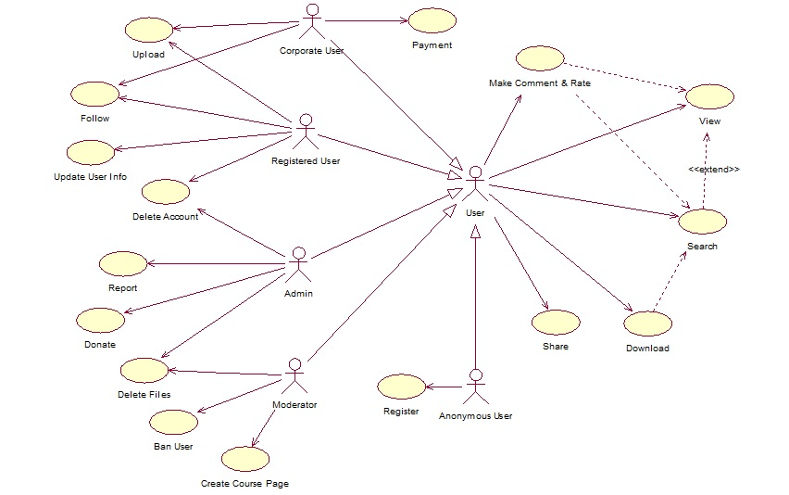

## 3.6 Activity Diagrams

**-Register**

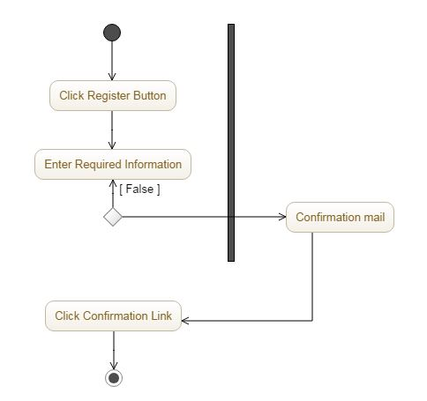

**-Search**

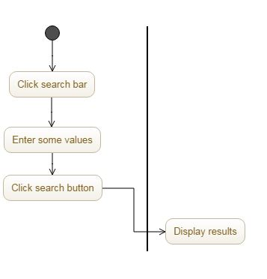

**-Make Comment&Rate**

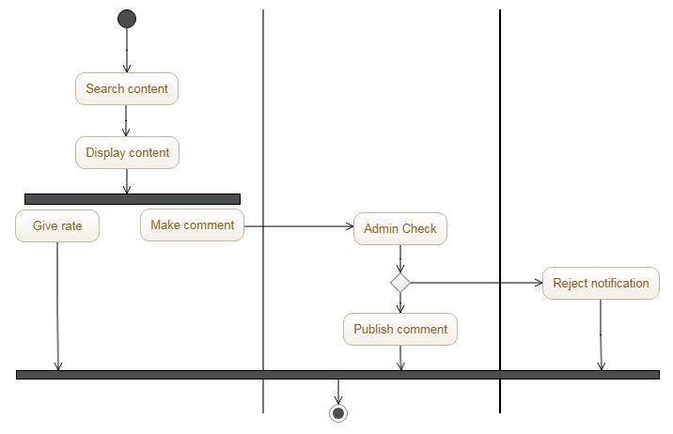

**-Download**

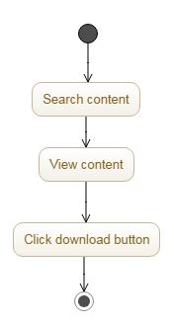

**-Upload**

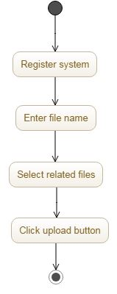

**-Follow**

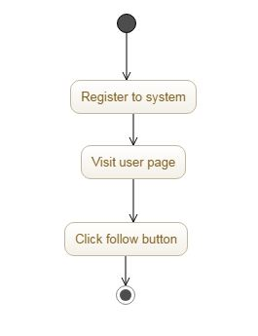

**-Payment**

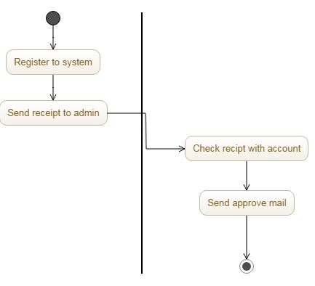

**-Share**

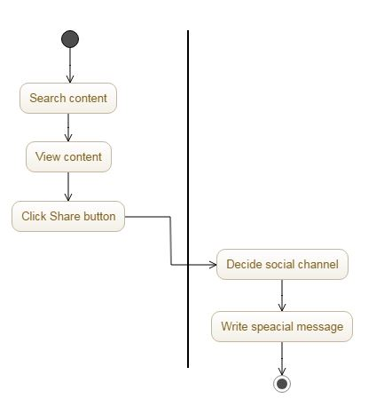

**-Account Delete**

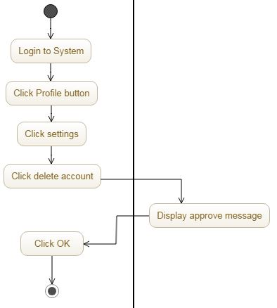

**-Update User Info**

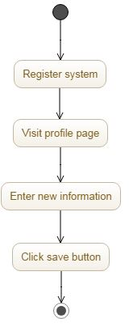

**-File Delete**

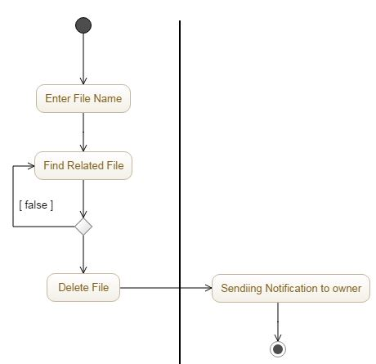

**-Course Page Creating**

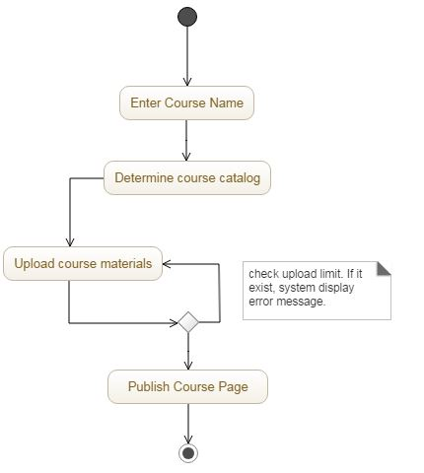

**-User Ban**

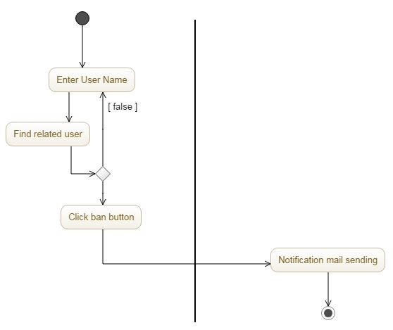

**-Reporting**

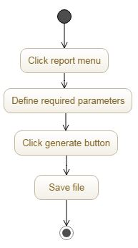

**-Donation to Charities**

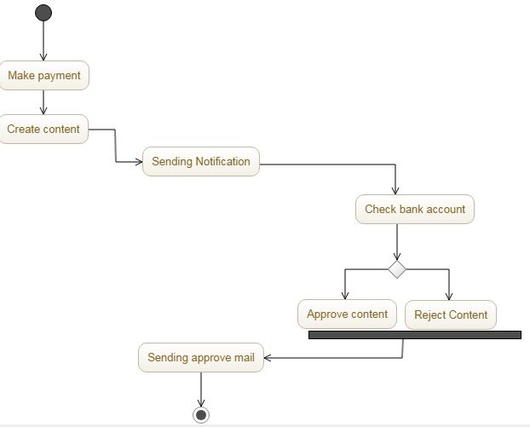

**3.7 Class Diagram**

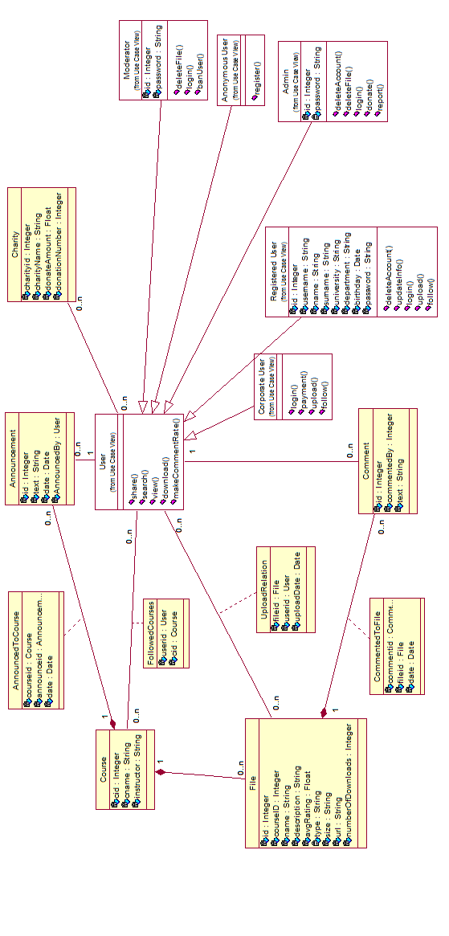

**3.8 Analysis Diagram**

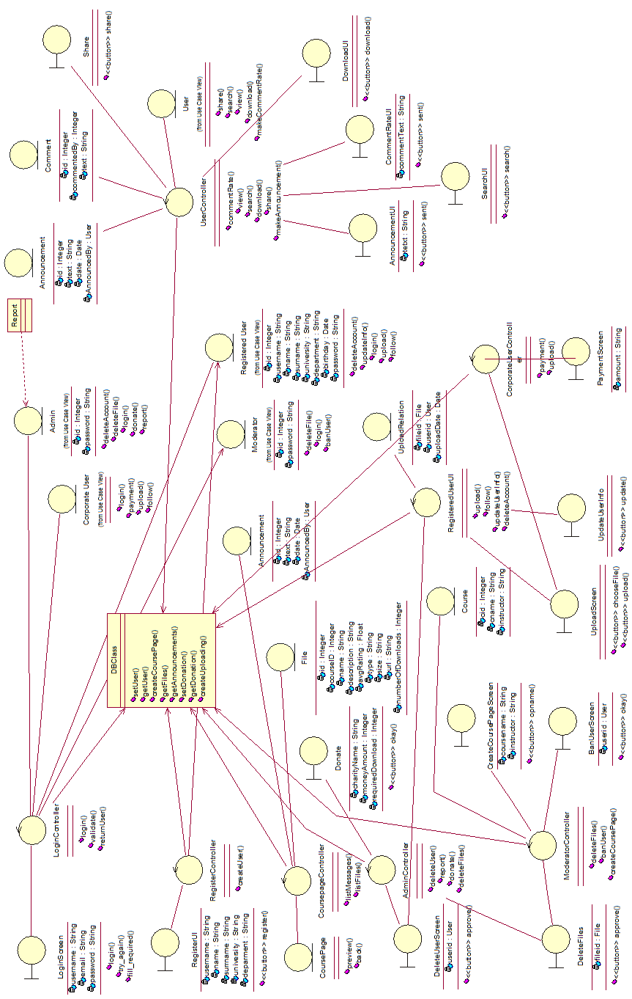

* 1. **Sequence Diagrams**

**-Search**

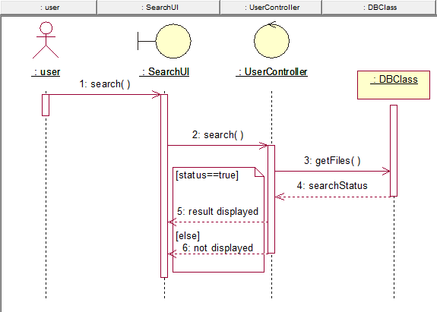

**-Update User Info**

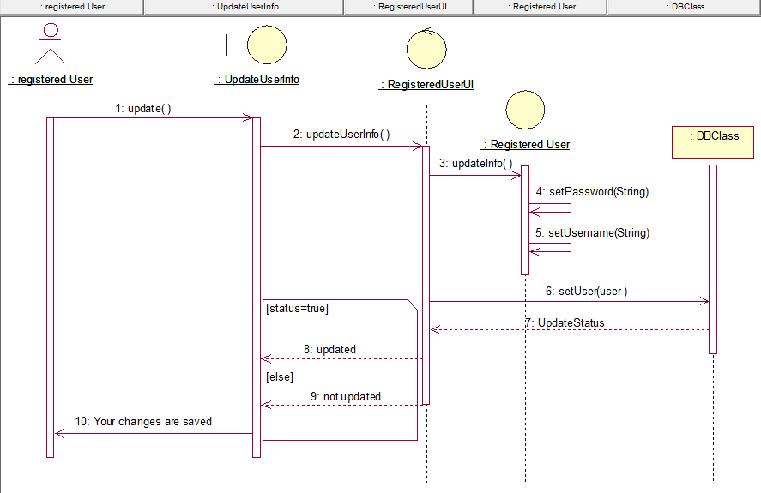

### 3.10 State Diagrams

**-Upload**

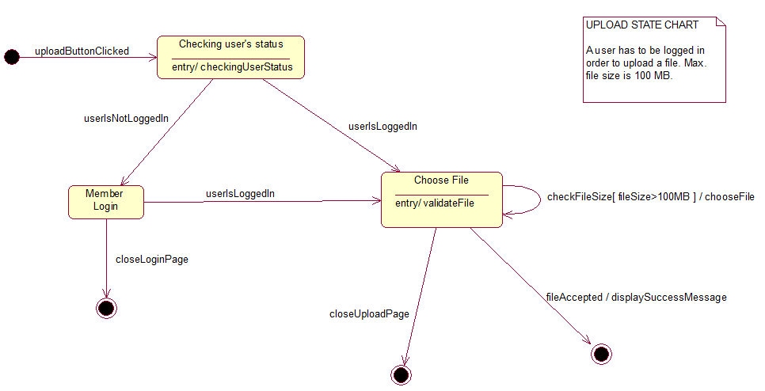

**-Download**

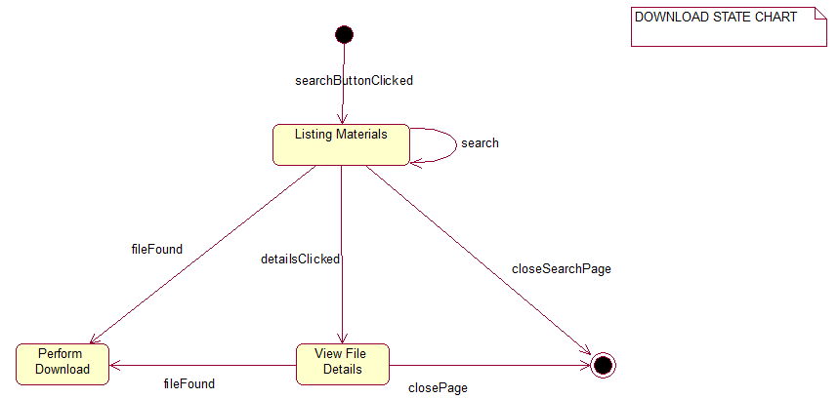

# 4. Appendixes

### 4.1 Survey Details

We created an online survey to understand students’ study habits and willingness to share their own study materials. Also we tried to learn their opinions on online platforms which they are used to reach or share study notes and materials.

Survey Link:

<https://docs.google.com/forms/d/e/1FAIpQLSfjBpTlEJUWN9B_7VwT5HdklkTgCRPhN5qkJ8k3NDwk9H4ctA/viewform>

91 participants participated our survey in different genders. First of all we try to learn their habits for studying and willingness to share their own study notes.The results show that more than half of the participants think that as only source,their own study notes are not enough to getting prepared for the exams. We can see that students need other people’s notes to feel fully ready for exams. Again, more than half of the participants think that the conventional methods (copy, books etc.) don’t provide enough source for preparing exams and they need other sources for reaching study notes.Also, we see that most of the students (47 students) are willing to share their own notes with others and 71 students think that sharing study notes with others don’t have effect on their own success. In addition, students (66 students) are more willing to share their notes,after they pass that lesson.Then we tried to learn how students use internet to reach study materials and we saw that the great majority of students use internet to search and find study materials.

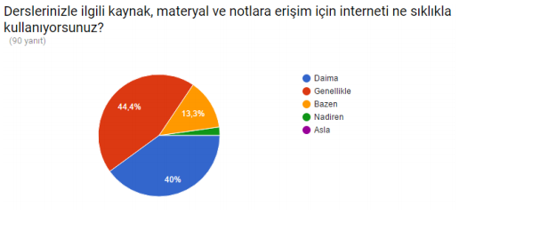

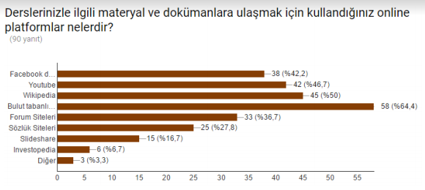

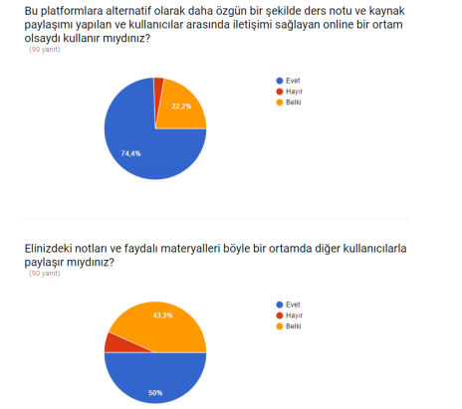

As a result we can say that students highly use internet platforms to search and find

study materials and they are highly satisfied with ability of searching and finding study

materials on online platforms. Also they are willing to use and contribute a specific platform

for these purposes.

### 4.2 Context Diagram

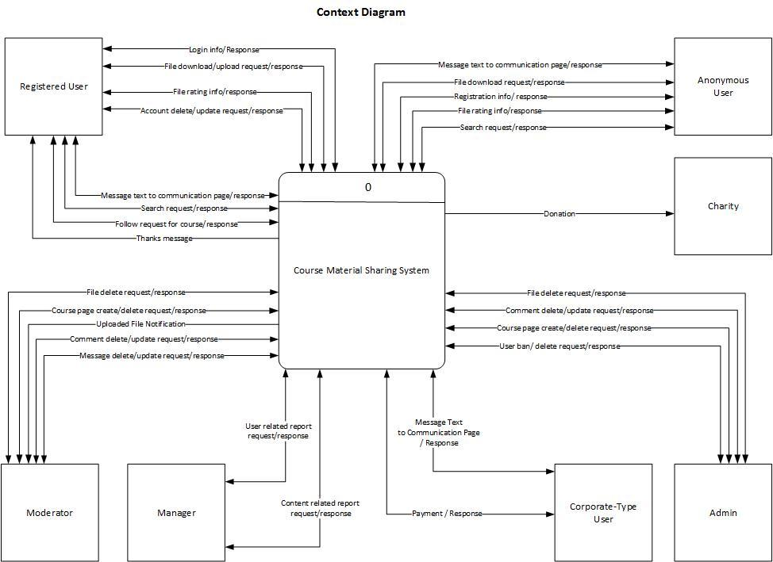

### 4.3 User Interface

**Home Page**

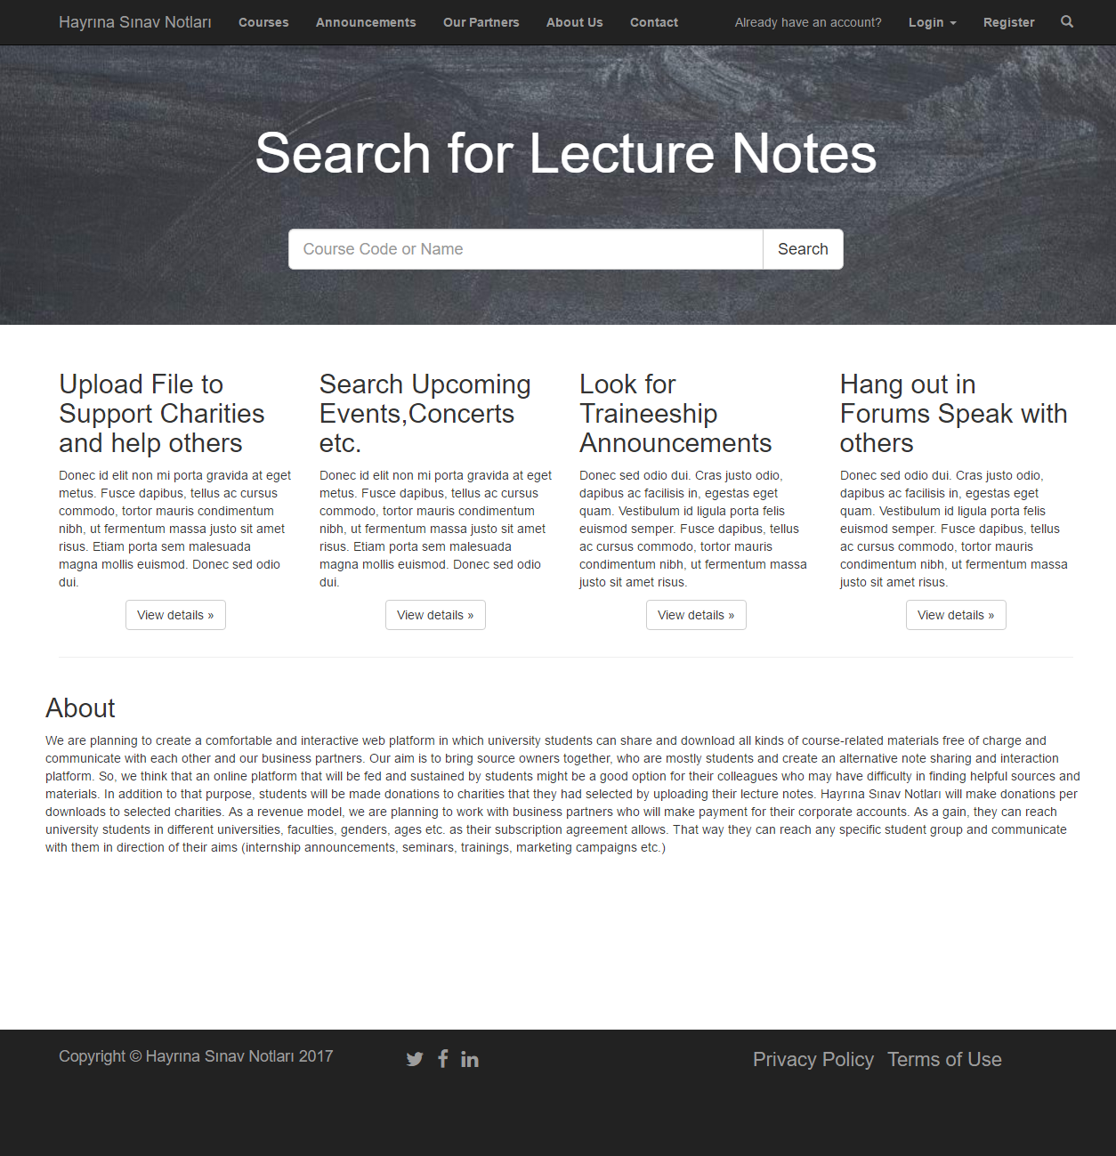

**Login**

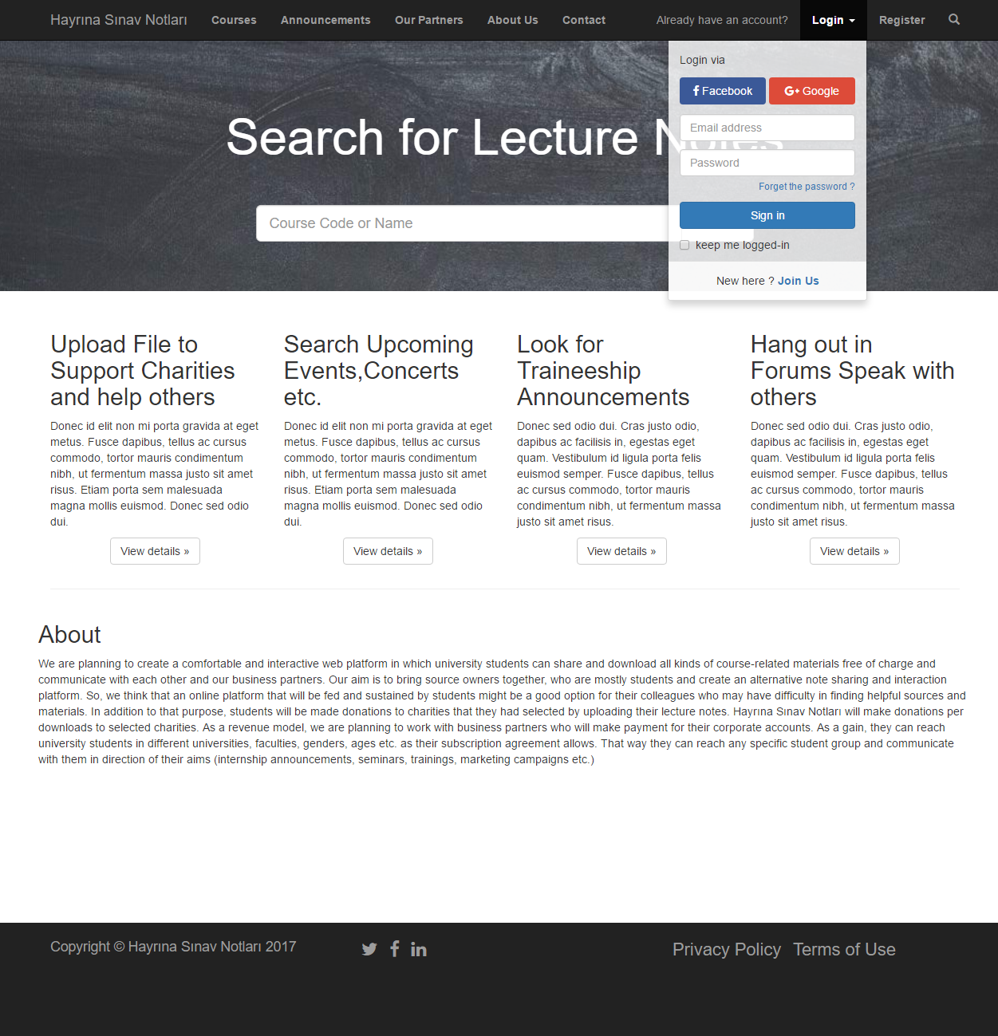

**Registration**

